TITLE OF THE PAPER (PAPER)
ABSTRACT (abstract)
(ABSTRACT_TEXT) The short summary in English no longer 10 lines. The authors are asked to use the text editor Microsoft© WORD. Maximum length of the paper is 8 pages – this limit has to be kept. Following format and predefined styles should be kept. Appropriate styles are written in the brackets behind the examples. MULTIPLE using of SPACE BAR and TABULATOR are PROHIBITED. Using of this template for paper writing is highly recommended.
Key words: (KEY)
(KEY_TEXT) written in English, no more than 5 words, dot in the end.
- TITLE OF SECTION (section)
  - TITLE OF SUBSECTION (subsection)
(NORMAL) The equations (BOLT) used in the paper should be numbered and written with an Equation Editor (ITALIC). The number of the formula should be written in round brackets by Arabic letters at the right margin of the page (use style equation, behind equation use TABULATOR).
Every equation should be followed by an explanation of used symbols (style EQUA_EXPL). Behind explanation is used 1 blank line. Format: style Equation, font ARIAL 13b; symbols, small and capital letters font Symbol, Variables 13b - italics, Index 9b, lowered index 6b, Symbol 20b, Smaller symbol 13b.; mathematical operators and constants (e.g.: sin, e, π, …) Arial 13b as usual.
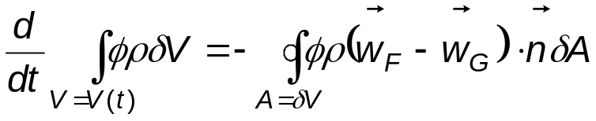 (1)
where: d – explanation (EQUA_EXPL)
V – explanation
1 blank line (NORMAL)
The pictures and graphs should be only high quality which can be copy. Used style - PICTURE. For title of figure use style – FIGURE.
(PICTURE)
Figure 1 - This is a picture (FIGURE)
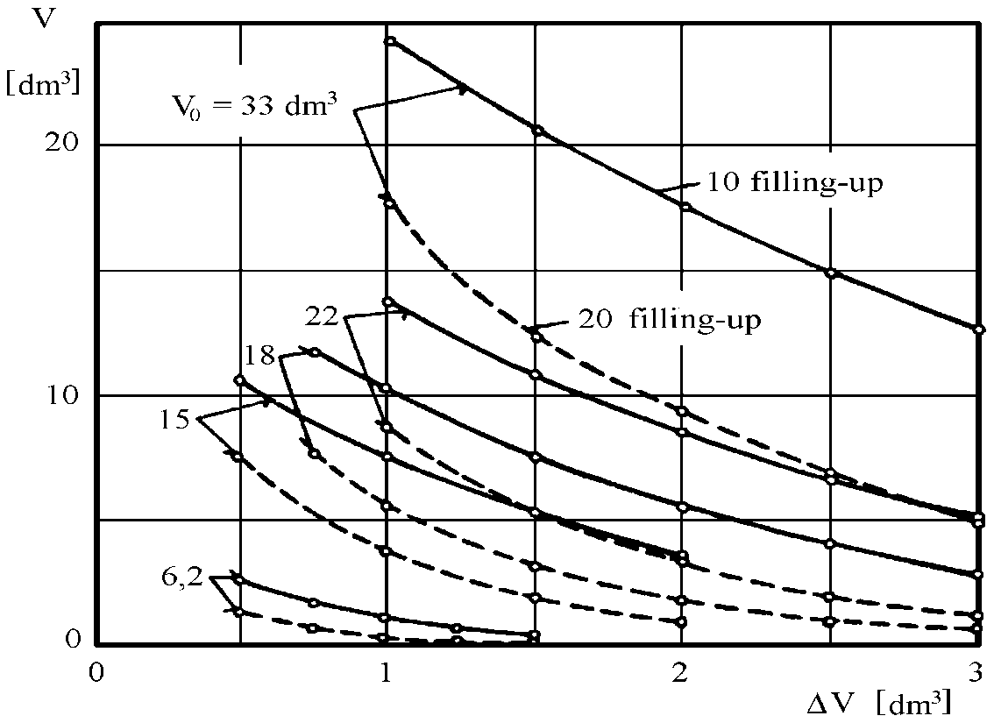(PICTURE)
Figure 2 — This is a graph (FIGURE)
For title of table use style – TABLE and for text at the table use style – (TABLE_TEXT). Behind table is used 1 blank line.
Table 1 - This is a table (TABLE)
GROUPS | I | II | III | IV
Sd (%) | 6.35 | 8.33 | 8.33 | 14.30
1 blank line (NORMAL)
Titles of acknowledgment and references are not numbered, use style - REFERENCES. Acknowledgement is written by normal style. For references use style – REF_TEXT (automatically numbered). References are arranged in order of their publishing in the text.
At the end of the references is used 1 blank line, author(s) name(s) (AUTHOR BOLT) their contact information (AUTHOR) and Section – Deterioration, Dependability or Diagnostics (AUTHOR BOLT).
- Conclusion
The papers shall be submitted in an electronic form only. It can be sent electronically to jiri.stastny@unob.cz, david.valis@unob.cz or posted on a CD, DVD or a memory stick to the postal address (Assoc. Prof. Jiří Šťastný, CSc., University of Defence Brno, Kounicova str. 65. K 202, 662 10 Brno, Czech Republic). All papers will be reviewed by the organizing committee and the selected ones will be presented in the form of lectures. Other papers should be presented in the form of posters. The form of the paper presentation will be announced to the authors well before the conference via an email. There has to be no space if the text starts on a new page or if the text starts directly after the first level title. Should you need any help, please, do not hesitate to contact the organizing committee. Contact address can be obtained from http://events.vojenskaskola.cz/3D.
acknowledgment (REFERENCES)
Presented work has been prepared with the support of….. (NORMAL)
REFERENCES (REFERENCES)
- AUTHOR A., AUTHOR C. Monograph: Wear, Reliability, and Diagnostics. Tribun EU. First edition. Brno, 2009, pp. 185-196. ISBN 978-80-7399-847-9 (REF_TEXT)
- AUTHOR A., AUTHOR C. Monograph: Wear, Reliability, and Diagnostics. Tribun EU. First edition. Brno, 2009, pp. 185-196. ISBN 978-80-7399-847-9
1 blank line (NORMAL)
Jíří Šťastný (AUTHOR BOLT)
Title: Eng. Ph.D. (AUTHOR)
E-mail: Vlastimil.neumann@unob.cz
Phone: +420 973 442671
Organization: University of Defence
Faculty of military technology
Address: Kounicova 65
662 10 Brno
Czech Republic
1 blank line (NORMAL)
David Vališ
Title: Assoc. prof. Eng. Ph.D.
E-mail: david.valis@unob.cz
Phone: +420 973 443422
Organization: University of Defence
Faculty of military technology
Address: Kounicova 65
662 10 Brno
Czech Republic
1 blank line (NORMAL)
Jiří šťastný
Title: Assoc. prof. Eng. CSc. (AUTHOR)
E-mail: jiri.stastny@unob.cz
Phone: +420 973 443658
Organization: University of Defence
Faculty of military technology
Address: Kounicova 65
662 10 Brno
Czech Republic
Section: Dependability (AUTHOR BOLT)

